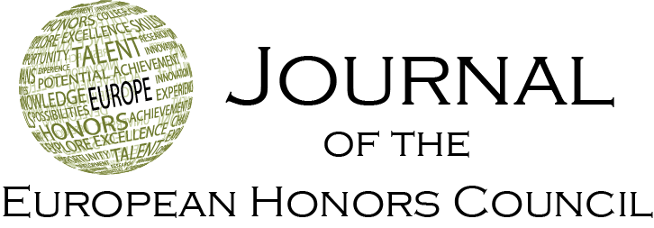

Note
Book review of Meaningful Assessment in Interdisciplinary Education: A Practical Handbook for University Teachers
Albert Pilot
Emeritus professor at Utrecht University
Correspondence: A.Pilot@uu.nl
Received: December 14th 2023; Accepted: December 18th 2023 ; Published: December 20th 2023
Keywords: higher education, assessment, interdisciplinary education, honors education, boundary crossing education

- Introduction
The authors stress the importance of assessment as an integral building block of all learning, particularly when assessment stimulates learning and is based on intrinsic motivation. This book focusses on twenty examples in higher education where teachers assess their students’ competences in innovative ways, such as integrating disciplines, cooperating, reflecting, and using critical thinking. Many examples are from honors programs in European higher education.
Teachers in higher education are increasingly challenged to facilitate learning beyond the boundaries of their own discipline and to come with innovative solutions for the important challenges in today’s society and the near future. Just as teaching and learning require adaption, testing and assessment methods also demand radical changes. This book provides many ideas and examples shared by university teachers who recognized this need and describe their experiences across a wide range of courses and students.
We see university teachers who, beyond transferring knowledge, aim to place greater emphasis on teaching students how to integrate knowledge, collaborate, think critically, and reflect. These teachers are not only breaking down the barriers between scientific disciplines, but also bridging the gap between academia and society, allowing different types of knowledge to play a role in academia. They are responding to the changing role of universities in society and the changing needs of a new generation of professionals. As teaching and learning evolve, so too must assessment. Teachers face the daily challenge of assessing students, but to assess more complex or higher-order skills-oriented learning outcomes that are common in interdisciplinary projects and courses poses a considerable challenge.
This handbook is of interest to you if you seek inspiration for implementing innovative assessment methods that assess higher-order skills and interdisciplinary learning outcomes. It points to new directions in assessment and provides illustrations of inspiring initiatives.
We are still at the onset of answering the question of how to meaningfully assess interdisciplinary learning outcomes. This book gives a kickstart by explaining interdisciplinary understanding and presenting ample examples of pioneers who show us how to produce the necessary changes to make our education future-proof.

2 Structure of the book
The book is divided in three parts. In the first part, ‘Getting Started with the Assessment Interdisciplinarity’, the authors begin by explaining why they think meaningful assessment drives student learning, and how feedback is a crucial element in learning. They also provide an overview of interdisciplinary understanding, including the necessary skills and knowledge, the use of authentic assessment, and the ways of aligning assessment with learning outcomes and with pedagogical beliefs and values. The chapter then delves into the assessment of skills that foster interdisciplinarity, discussing the concept of transdisciplinary subskills and learning outcomes. Subsections in this chapter focus on assessing integration, critical thinking, collaboration, and reflection.
The second part includes twenty examples of assessment methods used in practice. First, a short outline is given on how to navigate between the examples. The examples vary across a range of academic disciplines and institutional settings. All examples can be applied to courses and student projects with interdisciplinary learning outcomes or can be adapted in such a way that they can be applied within your course, regardless of the discipline from which the course stems.
The examples show methods to assess not only student work such as integrative papers, student portfolios and capstone presentations but also the outcome of simulation games, the learning process of students and the way students cooperate. The examples also explain how the change to meaningful assessment was implemented. The focus is on what innovation in assessment comprises, but also on the assessment methods themselves, with helpful formats, rubrics, and reflection questions. The intention is to provide a representative variety of inspiring good practices that cover the most important aspects of interdisciplinary understanding, and the authors were quite successful in my opinion.
In the third part of this book, ‘Towards New Ways of Assessment’, the lessons learned, and good practices found on the examples, are summarized. In addition, the steps to get started are outlined.
The authors wanted to share good practices of interdisciplinary skills assessment that are already used in higher education, including in honors education. This book will hopefully serve as a foothold for designing and implementing innovative assessment methods for projects and courses. Both lecturers and educational developers can take the examples given in this book and adjust them to fit their own situation, regardless of whether they are working on an interdisciplinary course or a course that focusses on more than one discipline.

I consider this book highly relevant for teachers in higher education, more specifically those in honors programs who frequently incorporate trans- and interdisciplinarity in their courses. Experiences and research involving innovative assessment methods will be also welcome for publication in this journal.

Book details
Authors: Ilja Boor, Debby Gerritsen, Linda de Greef and Jessica Rodermans
Publisher: Amsterdam, The Netherlands: Amsterdam University Press
ISBN: 978 94 6372 904 8
Date: 2021
Paperback, 154 pages

